City of Hanska April newsletter

**City Wide Cleanup** is scheduled for May 1st, 2nd and 3rd (Thursday, Friday and Saturday) 9:00 a.m. to 6:00 p.m.

**April 8th** – **City Council Meeting**

5:30 p.m. workshop, meeting to follow at 6:00 p.m. Located at the Community Center

Hanska Community Library

**Kids’ craft night** is April 14th at 5:30 p.m. Join us for a fun time at the library!

**April 15th Library board meeting** – 6:15 at the library, friends of the library meeting to follow.

**The Hanska Helpers are back to work**! These are kids and adult volunteers ready to help out in the community. They are available every Monday afternoon (weather permitting). Other days/times may be available by request. Call Angela (507) 327-0576 or stop in the library to request helpers for your project.



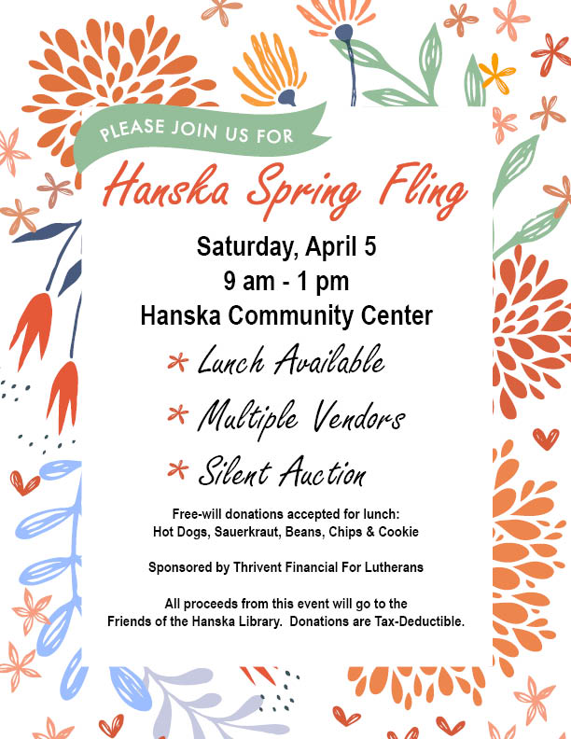

Dear Friends of Hanska, Lake Hanska, and Linden History, there will be gathering at Hanska Community Center at **1:00pm on Sunday, April 6th** to talk about the historic structures in the area. This is not a Brown County Historical Society sponsored meeting, but private individuals. This gathering is intended to be a conversation about the historical sites in and around Hanska, Lake Hanska, and Linden. We hope to discuss the current status of these sites and explore the possibility of collaborating on the maintenance and preservation of our shared history – the sites, structures, artifacts, and stories that define our communities. Please feel free to share this invitation with others who might be interested. We look forward to a productive and engaging discussion. Sincerely, Larry Harbo, Jeremy Berg, & Amy Johnson.