***City of Hanska February 2025***

201 Broadway PO Box 91

Phone: 507-439-6246

Email: hanska@sleepyeyetel.net

Hanska Women Of Today

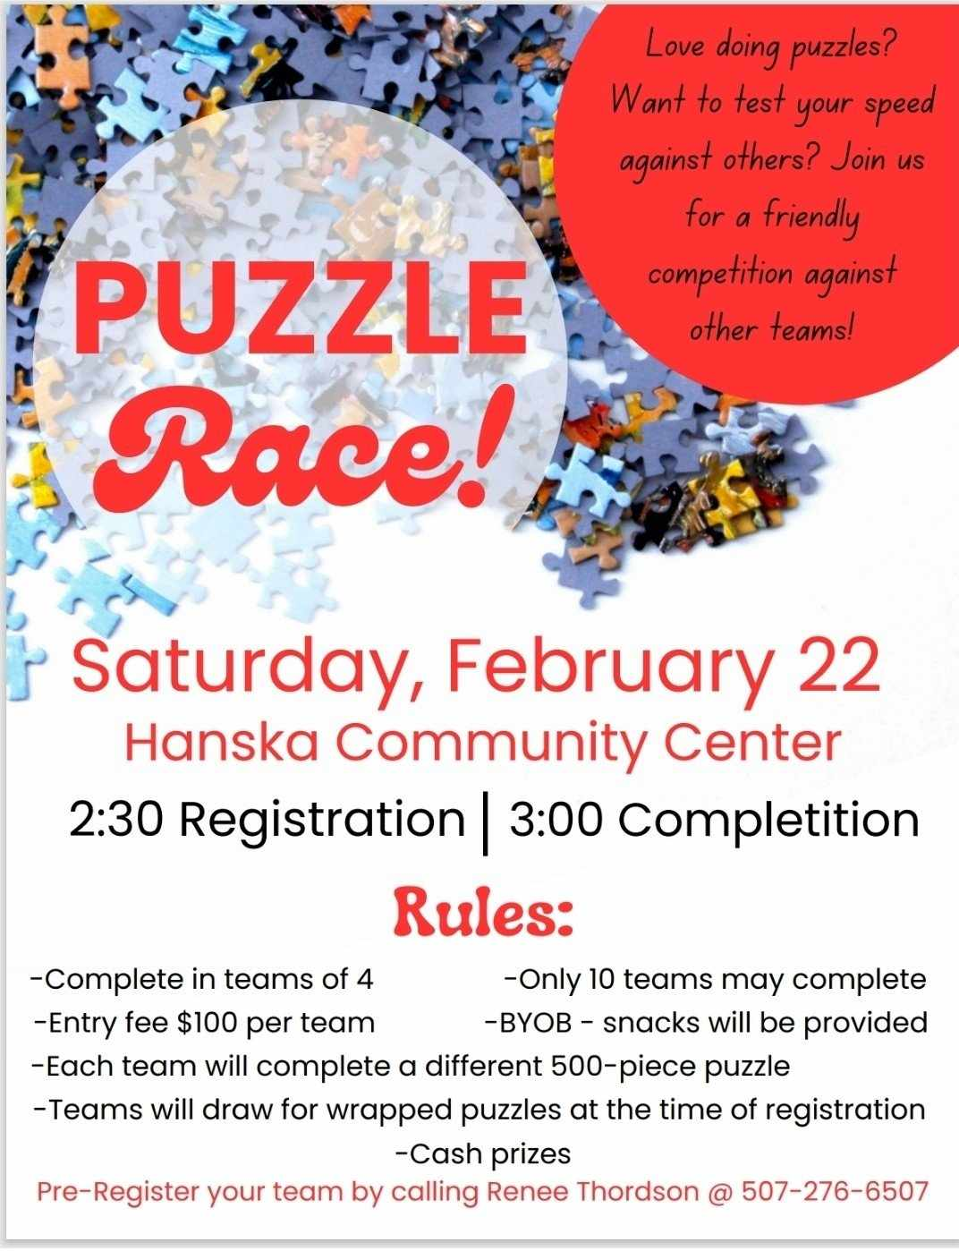

Hanska Fire Department

On behalf of the Hanska Fire Department, we want to extend a heartfelt thank you to everyone who attended and participated in our Ice Fishing Contest. Your support and enthusiasm made the event a great success! We truly appreciate your involvement and look forward to seeing you at future community events.

The Hanska Fire Department will be having their annual waffle breakfast in March. Date and time are to be determined. Please watch the Facebook page for updates.

Hanska Community Library

Hours

Monday-Friday 2:00-6:00 pm

Closed on February 17th

Saturday February 15th

Bingo & Mystery Wine Pull Fundraiser for the Friends of the Hanska Library.

Wine Pull starts at 2 pm

Bingo starts at 3pm

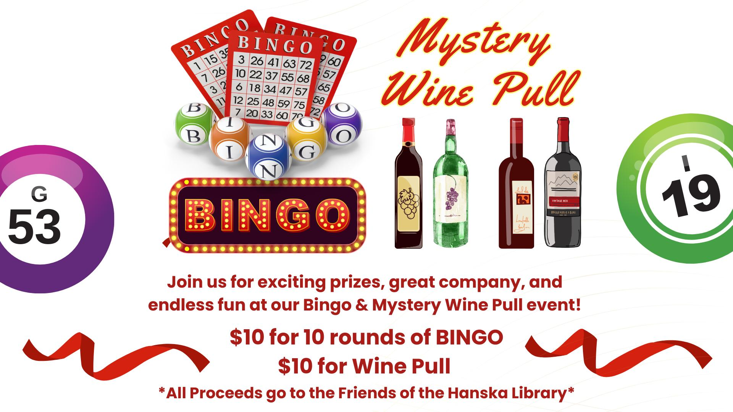

Now available to check out from the Hanska Library:  
Toniebox!

All you need is a library card.

