***City of Hanska March 2025***

201 Broadway PO Box 91

Phone: 507-439-6246

Email: [hanska@sleepyeyetel.net](mailto:hanska@sleepyeyetel.net)

Hanska Women of Today

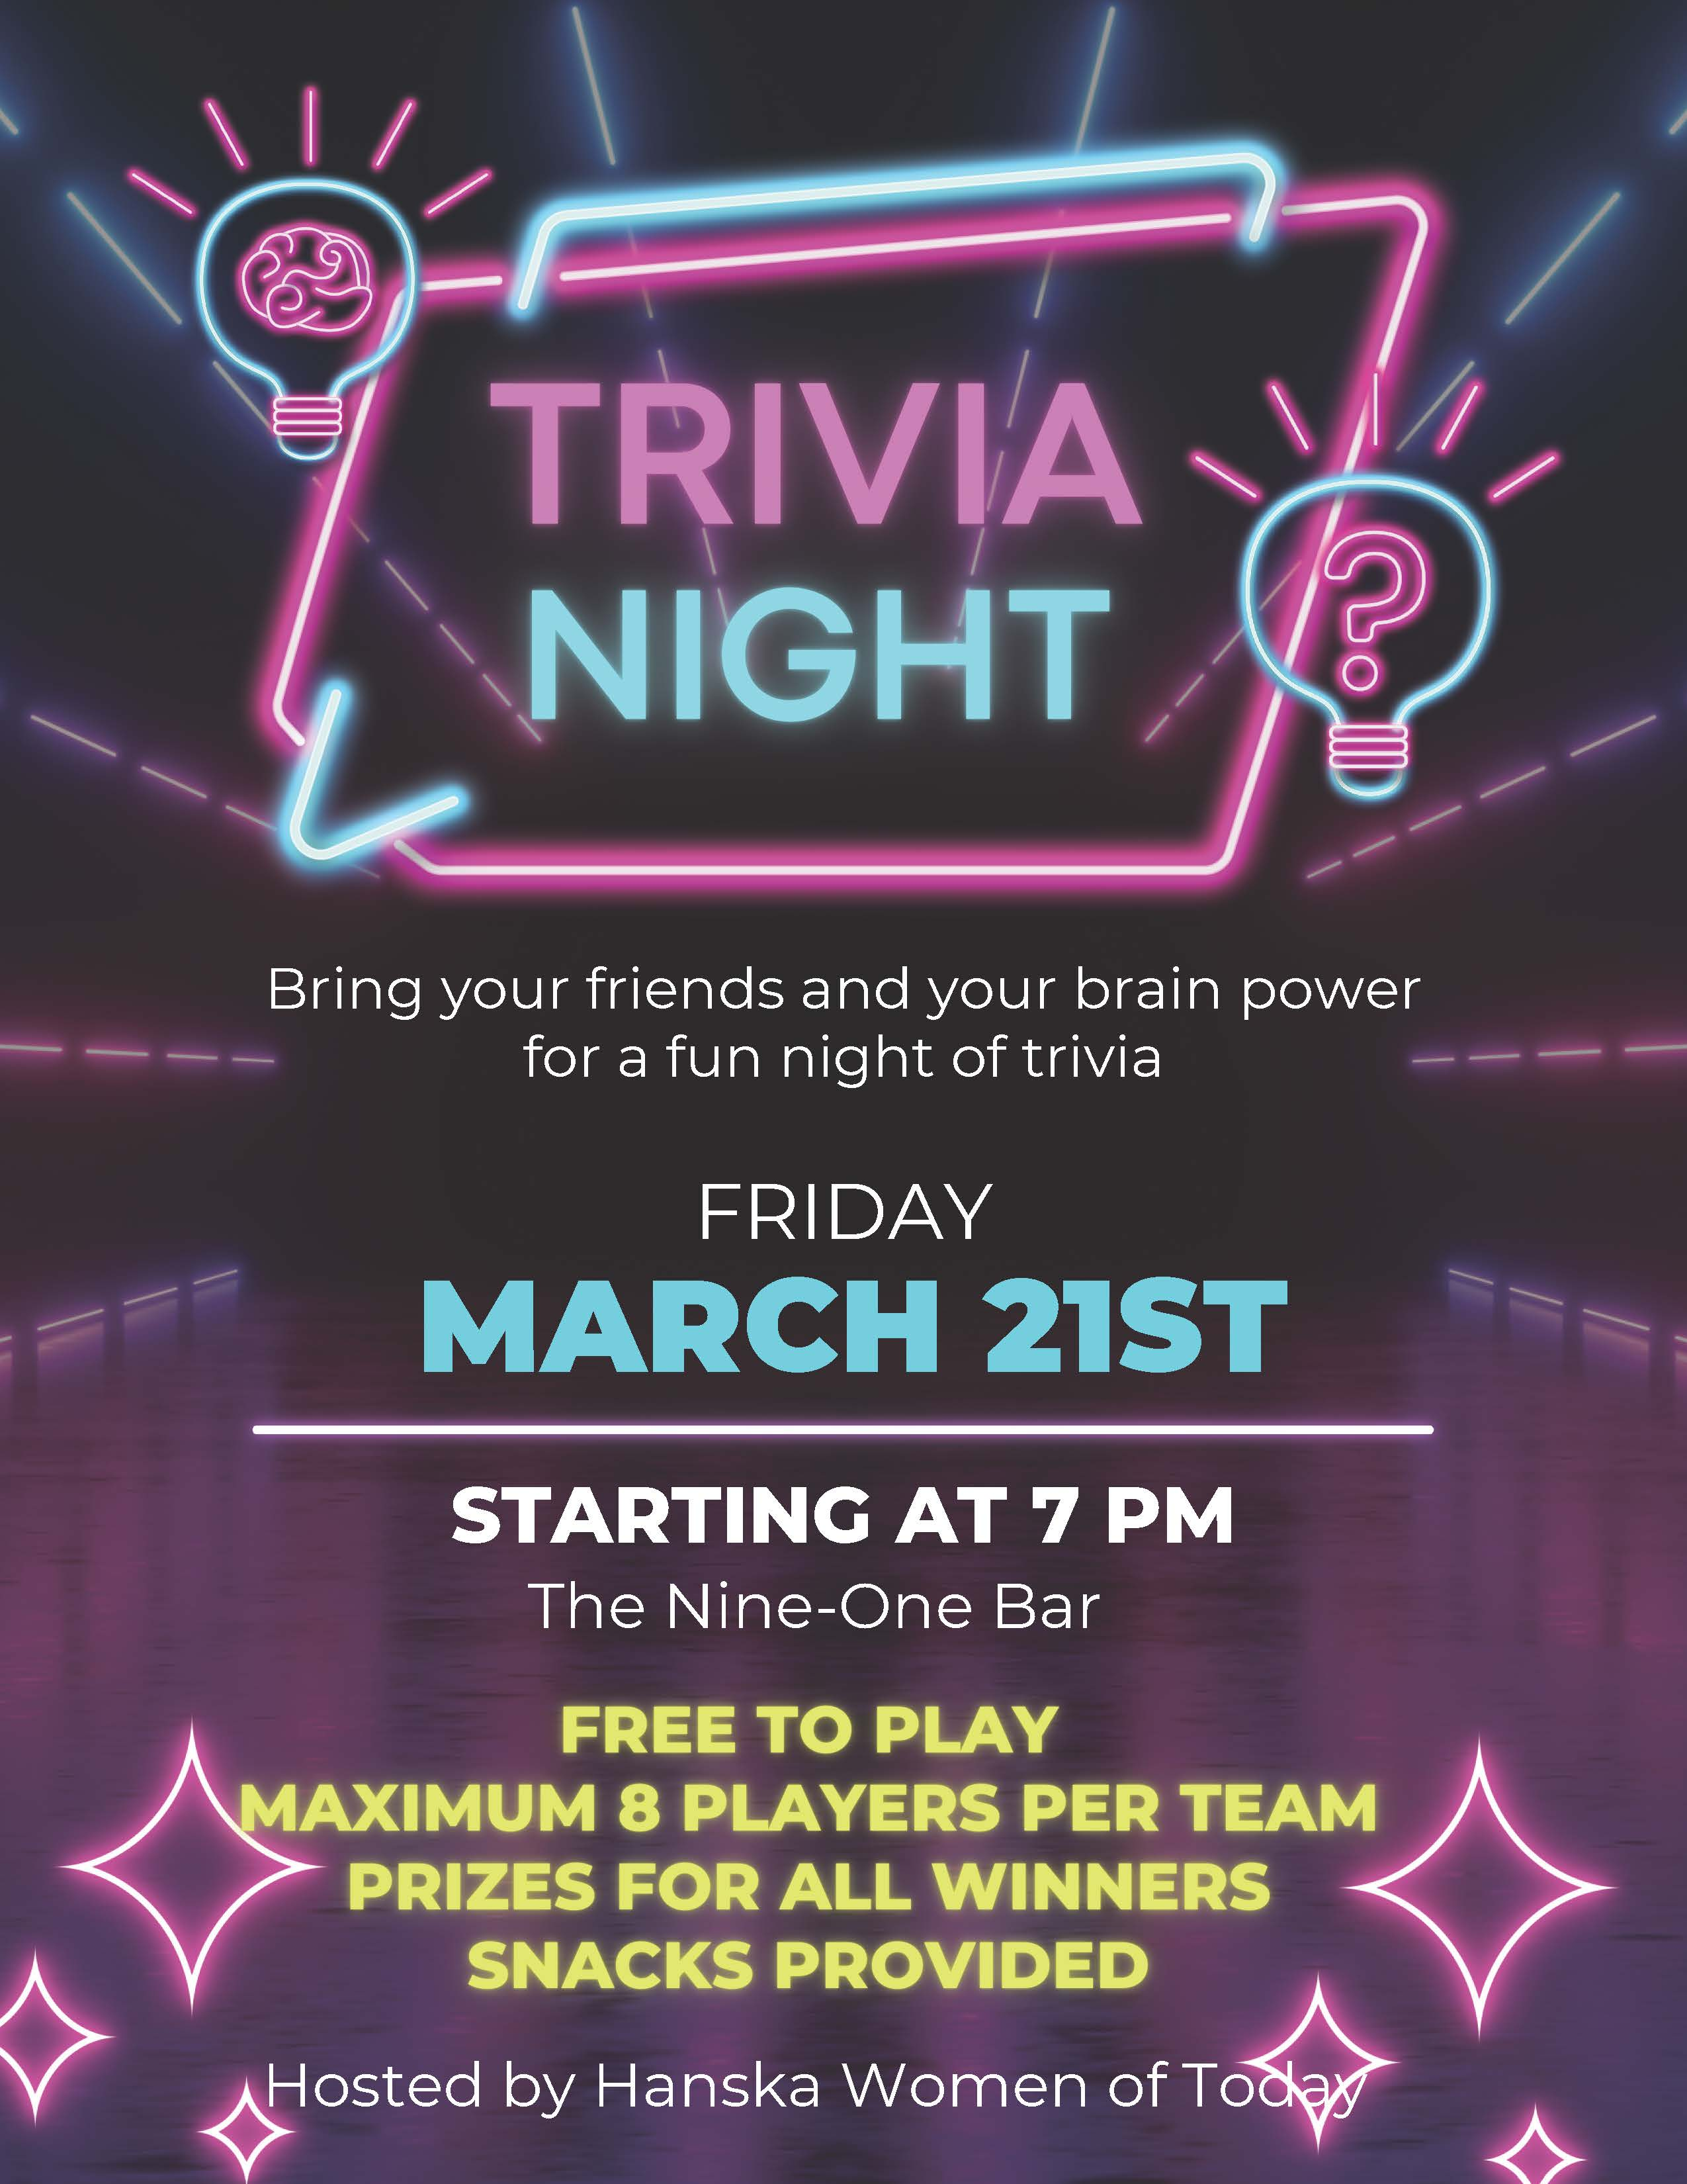

Hanska Fire Department

***Annual breakfast Sunday March 16th***

***8:00 a.m. to 12:00 p.m.***

Located in the lower level of the Community Center. 201 Broadway

Come and enjoy Hanska sausages & all you can eat Dad’s Famous Belgian Waffles.

Take outs & delivery available. Please call (507) 439-6248.

Hanska Community Library

Over $1000 was raised for the library in the bingo and wine pull. Thank you to everyone for your support.

Kids’ craft night is March 17th at 5:30 p.m. Join us for a fun time at the library!

Hanska Spring Fling is April 5th from 9:00 a.m. to 1:00 p.m. This event includes a vendor fair, lunch, and silent auction. Located at the community center.

***SPRING TIME REMINDERS***

SUMP PUMPS: IT IS ILLEGAL TO DISCHARGE INTO THE SEWER SYSTEM. FAILURE TO COMPLY WILL RESULT IN A $100 MONTHLY SURCHARGE WHICH WILL BE ADDED TO YOUR WATER/SEWER BILL.

**City Wide Cleanup** is scheduled for May 1st, 2nd and 3rd (Thursday, Friday and Saturday) 9:00 a.m. to 6:00 p.m.

BLOOD DRIVE

Located at the Hanska Community Center on Tuesday April 1st. Open from 12:00 p.m. to 5:00 p.m. Appointments can be made at **redcrossblood.org** or call

**1-800-REDCROSS**